FDA 304: One-page design document

This is a game design document modified from the original template (Underground, T.R.G.D. 2017).

## Programs/Programming Languages:

Unity 2021.3.9f1, Visual Studio Code/JetBrains Rider, C#, GIMP (GNU Image Manipulation Program), GitHub Desktop/Git, Adobe Photoshop, Adobe Fresco (iPad), Microsoft Visio (web).

## Game Identity / Mantra:

2D isometric shooter game set at nighttime.

## Design Pillars:

Intense, Excited, Thinking-ahead-of-time.

## Genre/Story/Mechanics Summary:

This is a 2D isometric shooter game where the player, named Marvin, must escape rooms and shoot enemies within a given time frame. The game is set in a city at nighttime.

## Features:

Melee combat, Ability to switch between combat modes,

## Interface:

WASD/Arrow Keys/Left Thumb stick: Movement.

Left Mouse/Right Trigger: Attack.

## Inspiration:

polyCaves (previous student project) (polyCaves by Sam Cox 2022).

Head over Heels (Belmont, H. 2018).

Max Payne (Gameboy Advance) (minimme 2017).

## Art Style:

(City of London at night.jpg 2005, December 21).

(Rainbow Bridge (Tokyo) at night 10.jpg. 2016, November 3).

## Music/Sound:

I am planning on adding action oriented sounds, to give the player a sense of adventure and thrill.

## Concept Art:

### Character Design Inspiration:

#### Marvin.

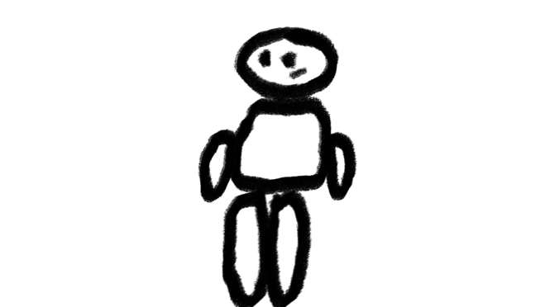

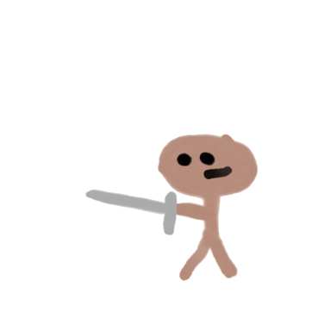

## Flowcharts:

Enemy Movement.

Player movement.

Collect items/points.

Character AI.

## Development Roadmap / Launch Criteria:

**Platform:** Android, iOS/iPadOS, Linux, macOS, Microsoft Windows.

**Audience:** 20-40/Male/Female/Interested in action games.

**License:** MIT.

|  |  |
| --- | --- |
| **Milestone 1:** Pre-Production complete - 07/02/23  **Milestone 2:** Milestone 2 complete - 27/03/23  **Milestone 3:** Levels complete - 27/03/23 | **Milestone 4:** Polish complete - 17/04/23  ---------------------------  **Launch Day:** 18/04/23 |

Bibliography:

Belmont, H. (2018) Head over Heels Remake (PC). Available at: <https://www.youtube.com/live/Nt2nTni0z4k?feature=share>.

City of London at night.jpg. (2005, December 21). Wikimedia Commons. <https://commons.wikimedia.org/wiki/File:City_of_London_at_night.jpg>

minimme (2017) Max Payne’s weird GBA port - minimme. Available at: https://www.youtube.com/watch?v=WOJ88WX-RWc.

polyCaves by Sam Cox (2022). Available at: <https://sam-cox.itch.io/polycaves>.

Rainbow Bridge (Tokyo) at night 10.jpg. (2016, November 3). Wikimedia Commons. <https://commons.wikimedia.org/wiki/File:Rainbow_Bridge_%28Tokyo%29_at_night_10.jpg>

Underground, T.R.G.D. (2017) Game Design Document Template - One Page + Super Easy. Available at: <https://www.youtube.com/watch?v=q96lz725gIw&feature=youtu.be>.